**MP 1 report Group 73**

**First we use scp to upload log file to VM: scp vm1.log** [**kaiqi3@fa18-cs425-g73-01.cs.illinois.edu:/home/kaiqi3/vm1.log**](mailto:kaiqi3@fa18-cs425-g73-01.cs.illinois.edu:/home/kaiqi3/vm1.log)

**Part 1:**

**We use grep4j to implement our design.**

**For each vm log, we create a profile.**

**The local profile is:**

|  |
| --- |
| **Profile localProfile = ProfileBuilder.newBuilder().name("Local server log").filePath("/home/zli104/vm1.log").onLocalhost().build();** |

**The remote profile is:**

|  |
| --- |
| **Profile remoteProfile_2 = ProfileBuilder.newBuilder().name("Remote server log2").filePath("/home/zli104/vm2.log").onRemotehost("fa18-cs425-g73-02.cs.illinois.edu").credentials("zli104", "Lzrgueen1996").build();** |

**Then use grep command to search patterns in all logs and return results..**

|  |
| --- |
| **String str = “<the pattern for grep>”;**  **GrepResults results = grep(constantExpression(str), on(localProfile, remoteProfile_2, remoteProfile_3, remoteProfile_4,**  **remoteProfile_5, remoteProfile_6, remoteProfile_7, remoteProfile_8, remoteProfile_9, remoteProfile_10));** |

**Result is:** 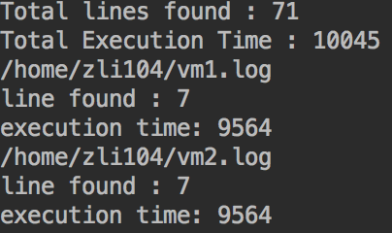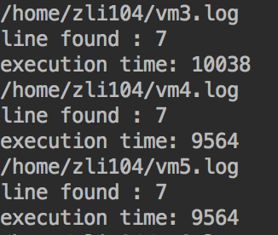

**Part 2:**

**We test the grep command to other VMs separately on each VM to check whether each VM can work properly. Then we can implement our formal grepping of log files.**

**Use assertThat to judge whether the results are correct:**

|  |
| --- |
| **assertThat(executing(results).totalLines(), is(70));** |

**the plot for five total execution time trials of three data points is:**

**The average execution time is 10597.6, 10453.5, 10694.3,**

**the standard variation is 614.5, 604.3, 610.7.**